1.

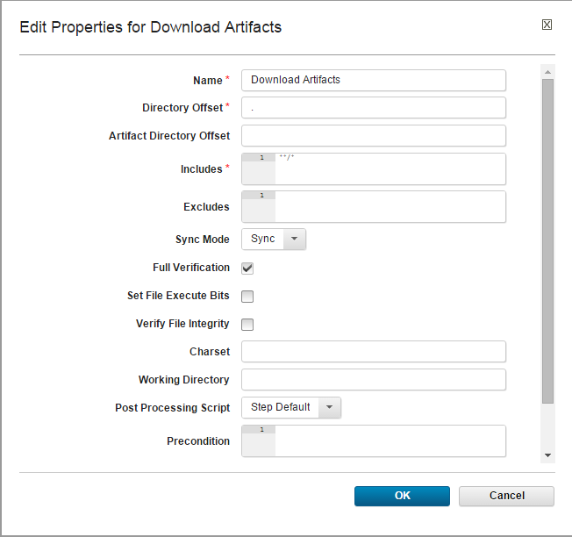

2.

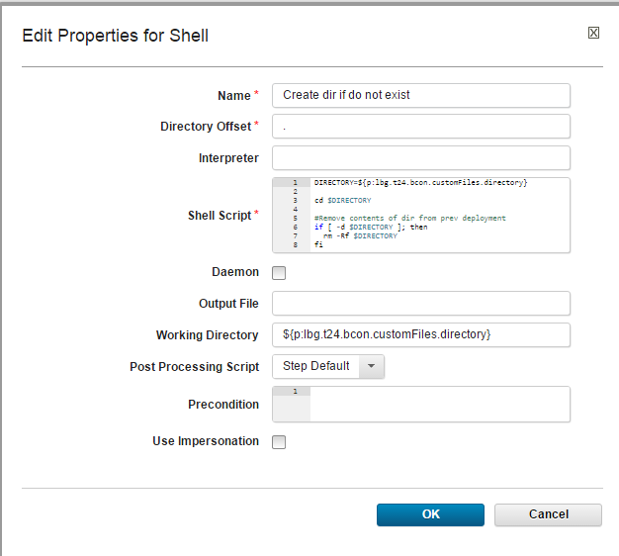

=============================== Shell script=================

DIRECTORY=${p:lbg.t24.bcon.customFiles.directory}

cd $DIRECTORY

#Remove contents of dir from prev deployment

if [ -d $DIRECTORY ]; then

rm -Rf $DIRECTORY

fi

TMPDIR=${p:lbg.t24.bcon.customFiles.tmp.directory}

#Also remove contents of tmpdir from prev deployment

if [ -d $TMPDIR ]; then

rm -Rf $TMPDIR

fi

#Create target dir if it donot exist along with tmp dir to extract becon zip

if [ ! -d $DIRECTORY ]; then

mkdir -p $DIRECTORY

fi

if [ ! -d $TMPDIR ]; then

mkdir -p $TMPDIR

fi

================================= =================

3.

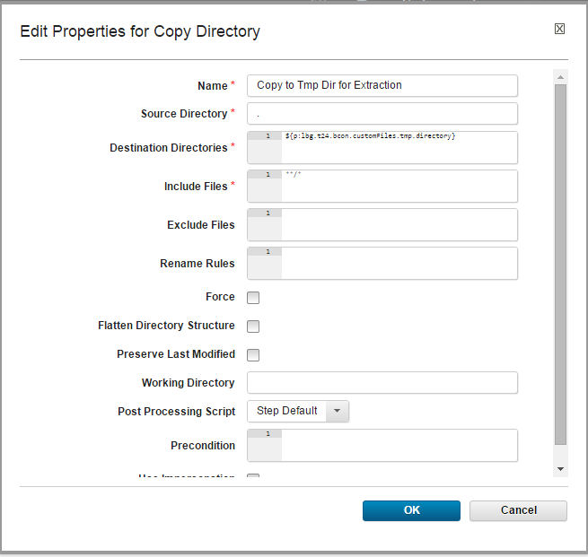

4.

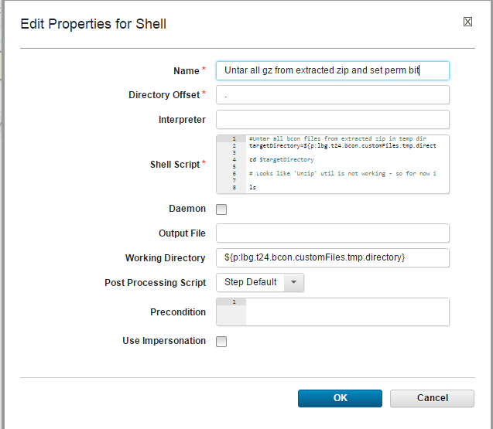

==========================Shell script===========================

#Untar all bcon files from extracted zip in temp dir

targetDirectory=${p:lbg.t24.bcon.customFiles.tmp.directory}

cd $targetDirectory

# Looks like 'Unzip' util is not working - so for now is unlinked & unzip-ing explicitly!

ls

unzip bcon.zip

# todo : As of this point it is unzipping under bcon/ dir :( Change by removing below line once it is handled at upload time

cd bcon

ls -1 *.gz | while read bcn; do tar -xvf $bcn; done

echo "Untarred all bcon gz files to $targetDirectory and below are list.."

# Remove extracted .gz files

rm *.gz

ls

# Giving full permission to all extracted dir contents in go - which (perm bits) will be retained in copy over

chmod -R 777 *

# todo : As of this point it is unzipping under bcon/ dir :( Change by removing below line once it is handled at upload time. Here moving contents to tmp dir

mv * ../../

# todo : Also next copy over is not working withing Ucd. Hence moving to required target dir

cd .. ; pwd ; ls

# Remote tmd dir created as well

rm -Rf $targetDirectory

=================================

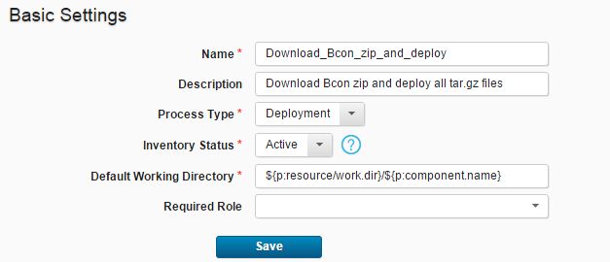

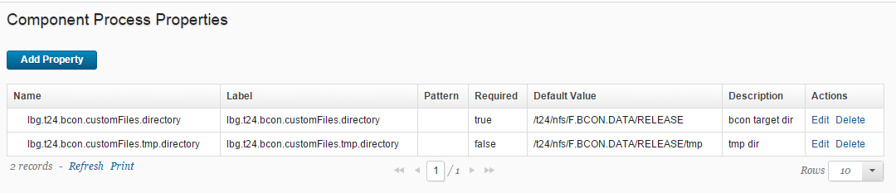

============================ END ============================

=================additional=================

